SALESFORCE REPORTS AND DASHBOARD DOCUMENTATION
Courier Management System
This document defines recommended Salesforce reports and dashboard components for the Courier Management System. It includes report configuration, filters, groupings, charts, dashboard setup, verification steps, and evidence areas for inserting Salesforce screenshots.

1. Purpose of Reports and Dashboards
- Analyze customer, shipment, agent, branch, delivery, and invoice data.
- Monitor courier operations using summarized and filtered information.
- Track shipment status, delivery progress, payments, and branch performance.
- Display key project information visually through dashboard components.

2. How to Create a Salesforce Report
1. Open Salesforce and go to the Reports tab.
2. Click New Report.
3. Select the required report type.
4. Click Start Report.
5. Add the required columns.
6. Apply filters such as date, status, branch, or payment status.
7. Add grouping fields when a summary report is required.
8. Add a chart if visual analysis is needed.
9. Click Save & Run.
10. Enter a report name and select a report folder.
11. Verify that the report displays the expected records.

3. Recommended Reports

3.1 Customer Report
Report Type | Customers
Recommended Columns | Customer Name, Email, Phone, City, State, Postal Code
Recommended Filters | All Customers or Created Date = Current Year
Grouping | State or City
Suggested Chart | Bar chart by State or City
Purpose | Shows customer distribution and contact information.
Implementation Status | Not confirmed - update after creating and testing the report in Salesforce.

3.2 Shipment Status Report
Report Type | Shipments
Recommended Columns | Tracking Number, Customer, Origin Branch, Destination Branch, Assigned Delivery Agent, Shipment Date, Expected Delivery Date, Status, Shipping Charge
Recommended Filters | Shipment Date = Current Month or required date range
Grouping | Status
Suggested Chart | Donut or bar chart by Shipment Status
Purpose | Tracks current shipment progress.
Implementation Status | Not confirmed - update after creating and testing the report in Salesforce.

3.3 Branch-wise Shipment Report
Report Type | Shipments
Recommended Columns | Tracking Number, Origin Branch, Destination Branch, Customer, Status, Shipment Date
Recommended Filters | Shipment Date = Current Month
Grouping | Origin Branch or Destination Branch
Suggested Chart | Bar chart by Branch
Purpose | Compares shipment volume across branches.
Implementation Status | Not confirmed - update after creating and testing the report in Salesforce.

3.4 Delivery Agent Performance Report
Report Type | Shipments
Recommended Columns | Assigned Delivery Agent, Tracking Number, Status, Shipment Date, Expected Delivery Date
Recommended Filters | Assigned Delivery Agent is not blank
Grouping | Assigned Delivery Agent
Suggested Chart | Bar chart showing shipment count by Delivery Agent
Purpose | Monitors shipment assignments and completed deliveries by agent.
Implementation Status | Not confirmed - update after creating and testing the report in Salesforce.

3.5 Delivery Update Report
Report Type | Delivery Updates
Recommended Columns | Update Number, Shipment, Status, Update Date/Time, Location, Remarks
Recommended Filters | Update Date/Time = Current Month or required range
Grouping | Status
Suggested Chart | Bar chart by Delivery Status
Purpose | Shows tracking history and delivery progress.
Implementation Status | Not confirmed - update after creating and testing the report in Salesforce.

3.6 Invoice and Payment Report
Report Type | Invoices
Recommended Columns | Invoice Number, Shipment, Invoice Date, Amount, Tax, Total Amount, Payment Status, Payment Method
Recommended Filters | Invoice Date = Current Month
Grouping | Payment Status
Suggested Chart | Donut chart by Payment Status
Purpose | Tracks invoicing and payment information.
Implementation Status | Not confirmed - update after creating and testing the report in Salesforce.

4. How to Create a Salesforce Dashboard
1. Open the Dashboards tab.
2. Click New Dashboard.
3. Enter a dashboard name such as Courier Management Dashboard.
4. Select a dashboard folder.
5. Click Create.
6. Click + Widget or + Component.
7. Select a source report.
8. Choose the required chart or metric type.
9. Configure title, labels, and display options.
10. Repeat the process for each dashboard component.
11. Arrange the components clearly.
12. Click Save.
13. Click Done and verify that all components display the expected data.

5. Recommended Dashboard Components
Dashboard Component | Source Report | Component Type | Purpose
Total Customers | Customer Report | Metric | Displays total customer count.
Total Shipments | Shipment Status Report | Metric | Displays total shipment count.
Shipments by Status | Shipment Status Report | Donut Chart | Shows Booked, In Transit, Out for Delivery, Delivered, and Cancelled shipments.
Shipments by Branch | Branch-wise Shipment Report | Bar Chart | Compares shipment volume across branches.
Agent-wise Shipments | Delivery Agent Performance Report | Bar Chart | Displays shipment assignments by delivery agent.
Delivery Status Updates | Delivery Update Report | Bar Chart | Shows the distribution of delivery update statuses.
Payment Status | Invoice and Payment Report | Donut Chart | Shows Pending, Paid, Failed, and Refunded invoices.
Total Invoice Amount | Invoice and Payment Report | Metric | Displays summarized invoice value when report summarization is configured.

6. Suggested Dashboard Layout
- Top row: Total Customers, Total Shipments, Total Invoice Amount.
- Middle row: Shipments by Status and Payment Status.
- Bottom row: Shipments by Branch, Agent-wise Shipments, and Delivery Status Updates.
- Keep chart titles short and clear.
- Use only components that provide useful operational information.

7. Report and Dashboard Verification
1. Confirm each report opens without errors.
2. Confirm report filters return the expected records.
3. Confirm grouped reports display correct totals.
4. Verify that charts reflect the report data correctly.
5. Confirm dashboard components use the intended source reports.
6. Refresh the dashboard and verify current data appears.
7. Check that users with the intended Profile and Role can access the reports and dashboard.
8. Add screenshots after successful verification.
Evidence / Screenshot
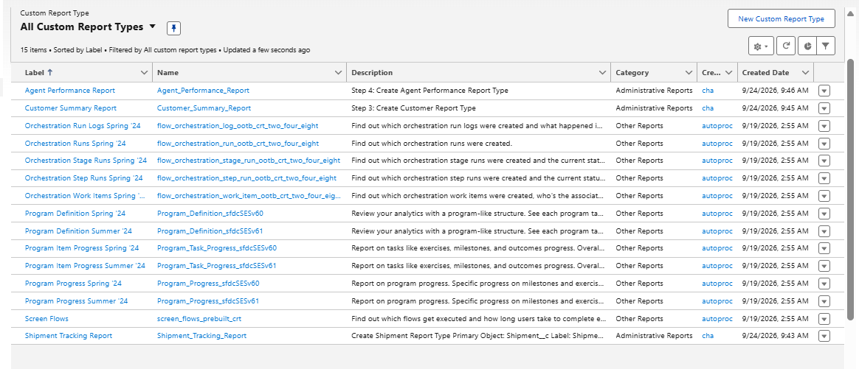

8. Final Verification Checklist
☐ Customer Report created and tested.
☐ Shipment Status Report created and tested.
☐ Branch-wise Shipment Report created and tested.
☐ Delivery Agent Performance Report created and tested.
☐ Delivery Update Report created and tested.
☐ Invoice and Payment Report created and tested.
☐ Courier Management Dashboard created.
☐ Dashboard components linked to correct source reports.
☐ Report filters and groupings verified.
☐ Dashboard refreshed successfully.
☐ Required users can access reports and dashboard.
☐ Screenshot evidence added to the document.

9. Important Notes
- The exact report types available depend on the object relationships and report types configured in your Salesforce org.
- If a related-field report type is unavailable, create a custom report type or use the nearest available standard/custom object report type.
- Dashboard data is based on its source reports, so verify reports before troubleshooting dashboard components.
- Use the actual field names and report names from your Salesforce org in the final submission.
- Do not mark reports or the dashboard as completed until they have been created, saved, run, and verified.

